1. **Right Angle Proof**

Given: <1 is a right angle; <2 is a right angle

Prove: <1 and <2 are congruent

|  |  |
| --- | --- |
| **Statements** | **Reasons** |
| <1 is a right angle; <2 is a right angle |  |
| m<1 = 90; m<2 = 90 |  |
| m<1 = m<2 |  |
| <1 and <2 are congruent |  |

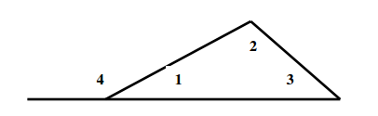

1. **Exterior Angle Theorem Proof**

Given: ∠4 is an exterior angle

Prove: m∠ 4 = m∠2 + m∠3

|  |  |
| --- | --- |
| **Statements** | **Reasons** |
| 1. ∠4 is an exterior angle | Given |
| 1. ∠ 4 and ∠ 1 form a linear pair |  |
|  |  |
| 1. m∠4 + m∠1 = 180 |  |
|  | Triangle sum theorem |
|  | Substitution |
| 1. m∠ 4 = m∠2 + m∠3 |  |

1. **Vertical Angles Proof**

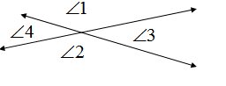

|  |  |
| --- | --- |
| **Statements** | **Reasons** |
|  |  |
|  |  |
|  |  |
|  |  |

1. **Parallel Sides Proof**

Word Bank:



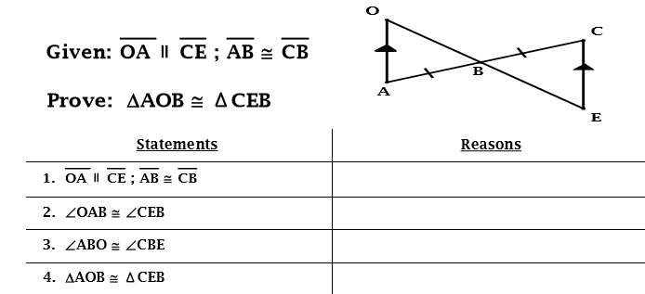

1. **Bisecting Lines Proof**

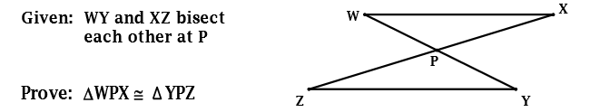

|  |  |
| --- | --- |
| **Statements** | **Reasons** |
| 1. WY and XZ bisect each other at P |  |
| $\overline{WP }≅\overline{YP}; \overline{XP}≅\overline{ZP}$ |  |
|  |  |
| $∆WPX ≅ ∆YPZ$ |  |

1. **Complementary Angles Proof**
2. **Alternate Interior Angles Proof**

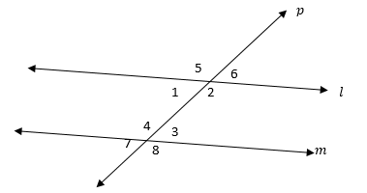

Given: $l∥m$

Prove: $∠1≅∠3$

|  |  |
| --- | --- |
| **Statements** | **Reasons** |
|  | Given |
| $∠1≅∠6$ |  |
|  |  |
| $∠1≅∠3$ |  |



1. **Alternate Interior Angles Proof**

Given: $l∥m$

Prove: $∠2≅∠4$

|  |  |
| --- | --- |
| **Statements** | **Reasons** |
|  | Given |
| 1. and are supplementary | Same – Side Interior Angles |
|  |  |
| 1. and are a linear pair |  |
| 1. and are supplementary | Linear Pair Theorem |
|  |  |
|  |  |
| $∠2≅∠4$ |  |

1. **Properties to Know:**

*You must know how to use these properties in a proof and be able to give an example for each.

|  |  |
| --- | --- |
| **Property** | **Example** |
| Substitution Property | If a = b, then you may replace b with a in any expression |
| Reflexive Property | a = a |
| Transitive Property | If a = b and b = c, then a = c |
| Addition Property of Equality | If a = b, then a + c = b + c |
| Subtraction Property of Equality | If a = b, then a – c = b – c |

1. **Definitions, Theorems, and Postulates to know:**

|  |  |  |
| --- | --- | --- |
| **Definitions** | **Theorems** | **Postulates** |
| Definition of Congruence | Pythagorean Theorem | SSS |
| Definition of Bisect | Vertical Angles | SAS |
| Definition of Supplementary Angles | Alternate Interior Angles | HL |
| Definition of Complementary Angles | Complementary Angles | AAS |
|  | Right Angle Theorem | ASA |
|  | Linear Pair | Segment Addition Postulate |
|  | Triangle Sum Theorem |  |

1. **CPCTC stands for:** ___________________________________________________________

**Mid – Segment Theorem**

**13. Solve for x and y**

1. **Solve for x and y**

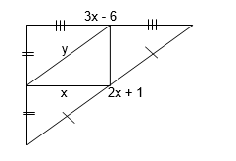

X = _________

Y = _________

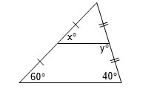

X = _________

Y = _________

1. **Solve for x**

**15. Solve for the missing length.**

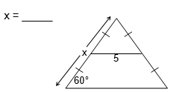

RQ = ________

