The inverse of an exponential function is a logarithmic function.
- Example: Find the inverse of f(x) = 3^{x}

- Example: Find the inverse of g(x) = log₂ x
Switch x and y values FIRST!

- Example: Find the inverse of f(x) = 3 + log₂ x

- Example: Find the inverse of f(x) = log₂ (x + 1) – 3

Graphing Logarithmic Functions: Find the inverse; graph the inverse of the inverse…
- Example: f(x) = 1 + log₄ x

- Exponential Form:
x Exponential  Graph Only Logarithmic Table | x Logarithmic | 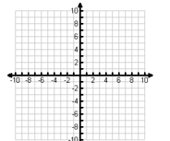
Determine the following for Logarithmic functions:  - Domain:  - Range:  - Vertical Asymptote: | Find the following for the logarithmic function:  f(x) = 1 + log₄ x  Domain: __________  Range: ___________  Asymptote: __________ | 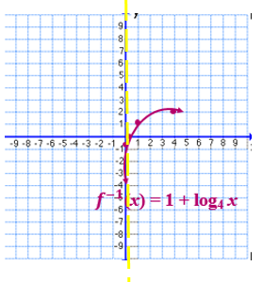
Graphing Logarithmic Functions: Find the inverse; graph the inverse of the inverse…
- Example: Graph $f\left(x\right)= \log_{3}{x}$

- Exponential form:

x Exponential  Graph Only Logarithmic Table | x Logarithmic
Determine the following for Logarithmic functions:  - Domain:  - Range:  - Vertical Asymptote: | Find the following for the logarithmic function:  $$f\left(x\right)= \log_{3}{x}$$  Domain: __________  Range: ___________  Asymptote: __________ | 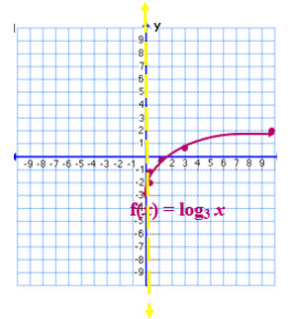
Finding x and y intercepts of a logarithmic function algebraically. ~Do NOT switch x and y~
- Example: f(x) = 1 + log₄ x  *First write the logarithmic function in exponential form.*  - Exponential form: | - Example: $f\left(x\right)= \log_{3}{x}$  *First write the logarithmic function in exponential form.*  - Exponential form:
Finding x – intercept: (Substitute 0 in for y) | Finding x – intercept: (Substitute 0 in for y)
Finding y – intercept: (Substitute 0 in for x) | Finding y – intercept: (Substitute 0 in for x)

