Geometry Name _______________________ 1.9 Practice: Base Angles, Exterior Angle Theorem & Isosceles
Use what you know about the sums of the interior and exterior angles of triangles to determine the measure of each identified angle.
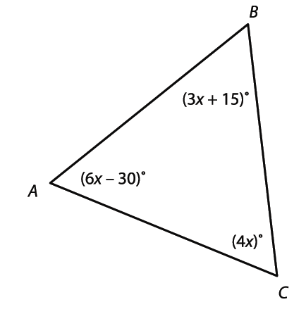
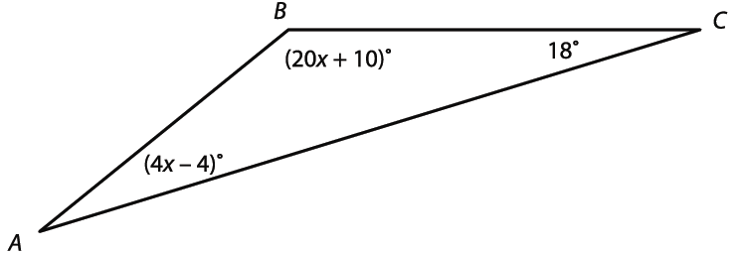
2. Find m∠A and m∠B. 3. Find m∠A, m∠B, and m∠C.

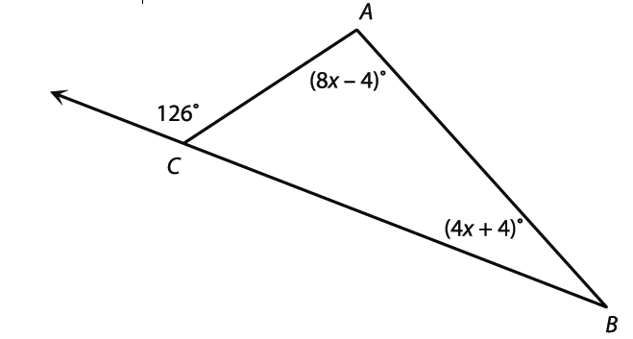
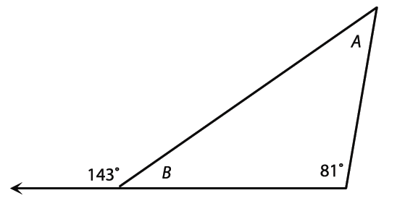
4. Find m∠A and m∠B. 5. Find m∠CAB and m∠ABC.

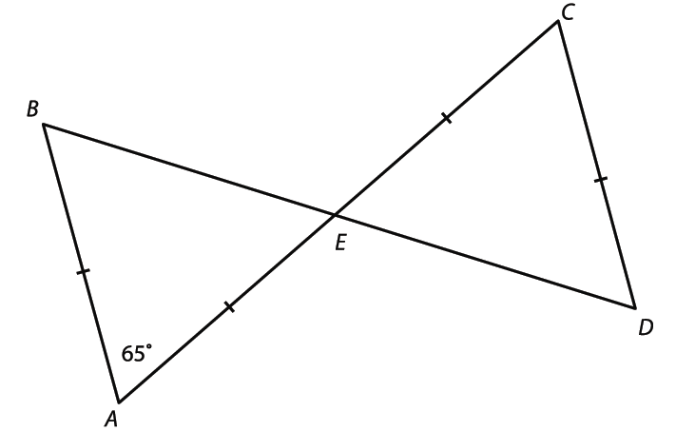
Use what you know about isosceles triangles to find each angle measure.
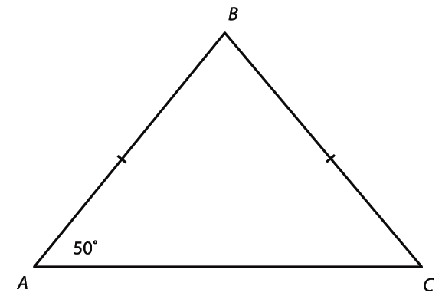
6. m∠B and m∠C 7. m∠B, m∠C, and m∠D

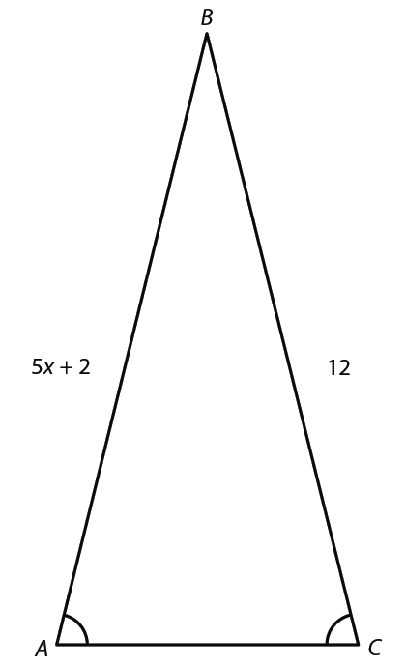

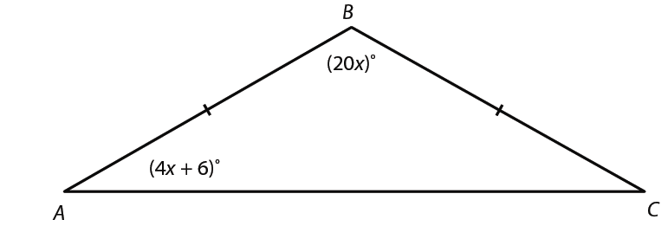
8. m∠A, m∠B, and m∠C 9. Find the value of x.

