### Name: __________________________________________ Date: _____________________________

**Volume of Prisms**

**Find the volume of each of the following and round to the nearest tenth.** 



1. _______

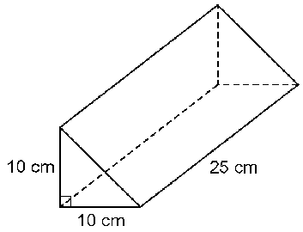

1. _______

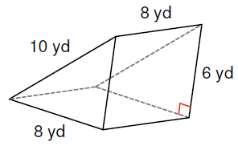

1. _______

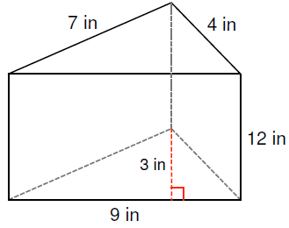

1. ________



1. ________