Name: ________________________________________________ Date: _______________________

**3 Ways to Prove Triangles are Similar**

**AA~ Postulate**:

If two angles of one triangle are congruent to two angles of another, then the triangles are similar.

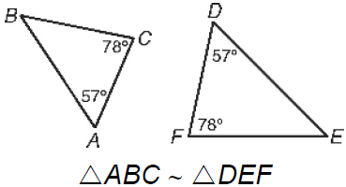

**SAS~ Postulate**:

If one angle of one triangle is congruent to the one angle of another triangle and the adjacent sides are proportional, then the triangles are similar.

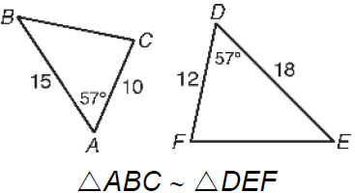

**SSS~ Postulate**:

If all three sides of one triangle are proportional to corresponding sides of another triangle, then the triangles are similar.

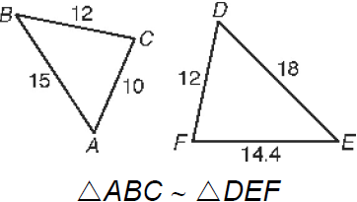

**Practice: Explain why the triangles are similar, and write a similarity statement.**

1. RQS~__________ by ______ 2) DEF~__________ by ______





1. ABC~__________ by ______ 4) ABC~__________ by ______

 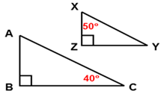

1. QPR~__________ by ______ 6) AEF~__________ by ______

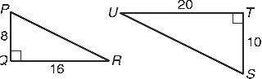 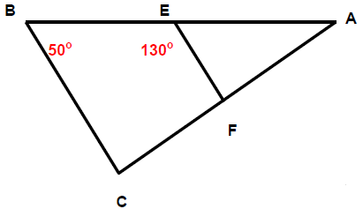

7) HGJ~__________ by ______ 8) RST~__________ by ______

 

**Explain why the triangles are similar, and find each length.**

9) Similar by ______ and GK = ____ 10) Similar by ______ and RQ = _____

 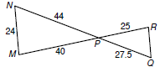

11) Similar by ______ and MN = ____ 12) Similar by ______ and DE = ____

