Geometry – Unit 4 Circles Review Name ____________________

Find the value of x. Round to the nearest tenth, if necessary.

1. 2. 3.



4. 5. 6.

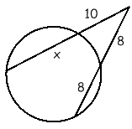



7. 8. 9.

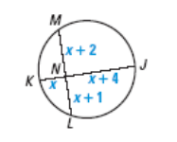 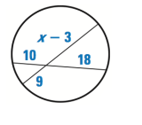

Find the value of the variable for missing angles or arcs.

 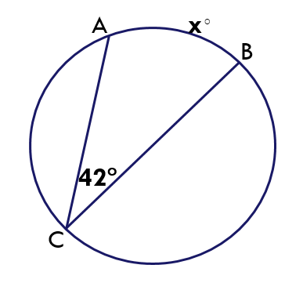 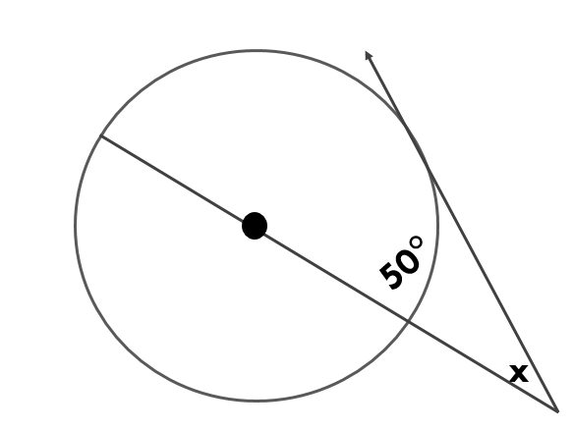

12.

11.

10.

15.

14.

13.

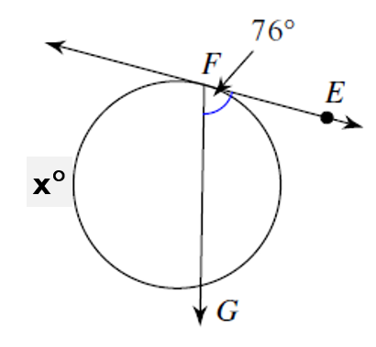 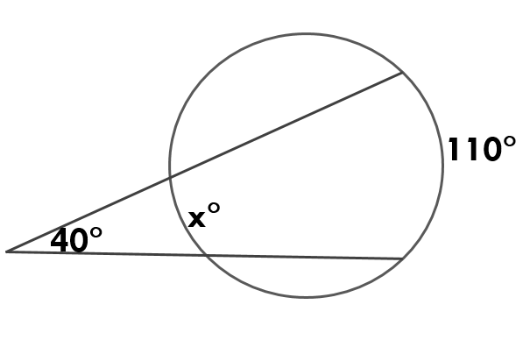 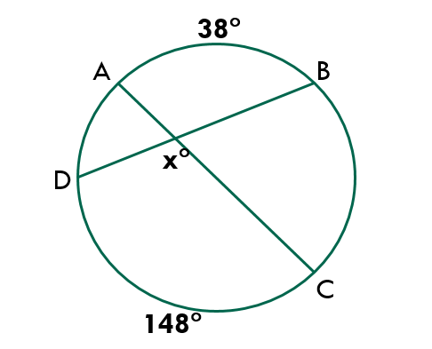

16.

17. Find 

18. Find the missing variables

