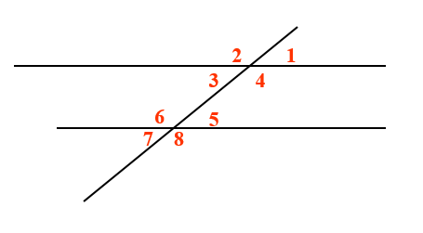
Definitions:
- Supplementary Angles:

- Vertical Angles:

- Corresponding Angles:

- Alternate Interior Angles:

- Alternate Exterior Angles:

- Same – Side Interior Angles:

- Same – Side Exterior Angles:

