Analytic Geometry Name ___________________________
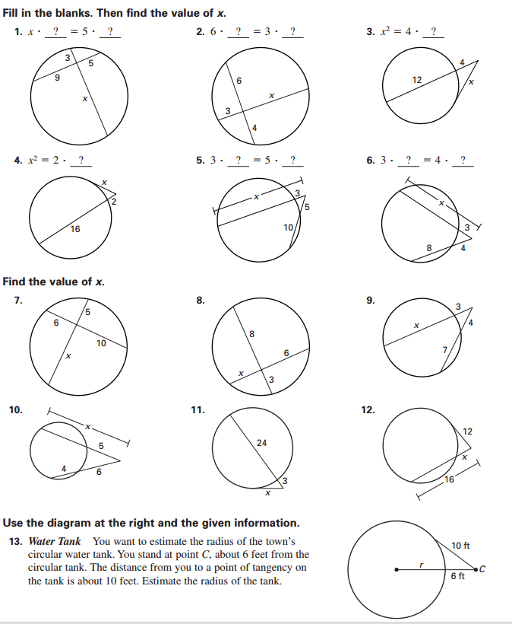
3.3.2 Practice: Segment Lengths Date ________________ Period______

