Name: ________________________________________________ Date: _______________________

Name the angle relationship: linear pair, vertical angles, or adjacent.

1. 2. 3.

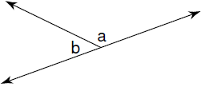 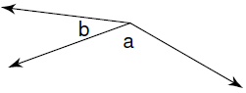 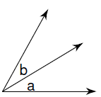

4. 5. 6.

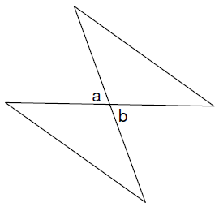 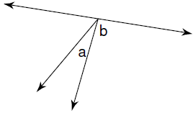 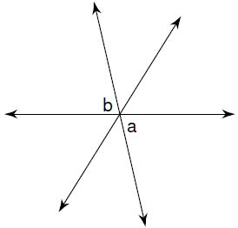

Use the diagram to tell whether the angles are vertical angles, a linear pair, or neither.

7. ∠ 1 and ∠ 2 _________ 8. ∠ 1 and ∠ 3 _________



9. ∠ 1 and ∠ 4 _________ 10. ∠ 1 and ∠ 5 _________

11. ∠ 1 and ∠ 6 _________ 12. ∠ 1 and ∠ 7 _________

13. ∠ 1 and ∠ 8 _________ 14. ∠ 2 and ∠ 4 _________



Solve for x.

15.  16. 17.

Solve for x.

18.  19.  20.

Use the diagram to find the indicated measure.

21. x = ______ 22. x = ______

m∠ ABD = _______ m∠ ABD = _______

m∠ DBC = _______ m∠ DBC = _______

 

23. x = ______

m∠ ABC = _______

m∠ DBE = _______

