Name: ________________________________________________________ Date: _______________________

**Equations of Circles – Homework**

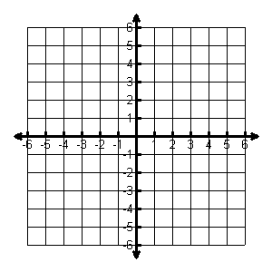**Graph the following circles. State the center and radius.**

1. 

Center: _______

Radius: ______

1. 

Center: _________

Radius: ________

1. 

Center: _______

Radius: ______

1. 

Center: _________

Radius: ________

1. 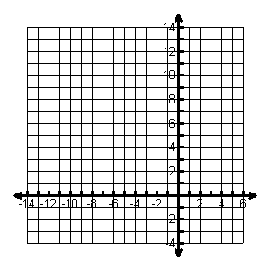

Center: _______

Radius: ______

1. 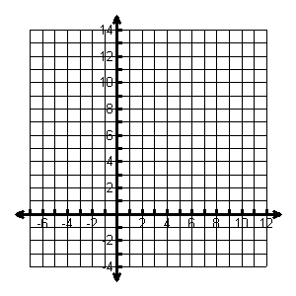

Center: _________

Radius: ________

**Write the equation of the circle in standard form. Then, convert to the general form.**

7. 8.

**Find the value of c that makes this a Perfect Square Trinomial, then write the expression as the square of a binomial.**

1. 
2. 
3. 

**Write the standard equation for the circle. State the center and radius.**

1. 
2. 
3. 
4. 