### Name: __________________________________________ Date: _____________________________

**Arc Length Homework**

Find the length of .

1) 2)

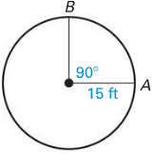 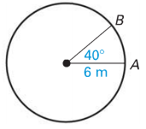

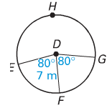

3) Find the length of .

4) Find the length of .

5) Find the perimeter.

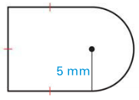

6) Convert the following degree measures to radians.

1. 30° b) 60º c) 210°

7) Convert the following radian measure to degree measures.

1.  b)  c) 

**Word Problems**:

8) Mrs.Noonan ran 4 times around a circular track that has a radius of 40 meters. What’s the total distance she ran?

For questions 9 – 10, use the clock below.

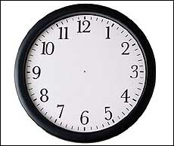

9) How many degrees does the minute hand move in 30 minutes? 40

minutes? 60 minutes?

10) If the minute hand is 4 inches long, what is the arc length covered

by the minute hand in 40 minutes?

11) A pie is cut into 6 equal pieces. The arc length of 1 piece of pie is 5.4 cm. What is the diameter of the pie?