Polynomials Patterns Task
- To get an idea of what polynomial functions look like, we can graph the first through fifth degree polynomials with leading coefficients of 1. For each polynomial function, make a table of 6 points and then plot them so that you can determine the shape of the graph. Choose points that are both positive and negative so that you can get a good idea of the shape of the graph. Also, include the x intercept as one of your points.

- For example, for the first order polynomial function: 𝑦 = 𝑥¹. You may have the following table and graph:

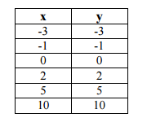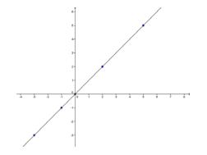
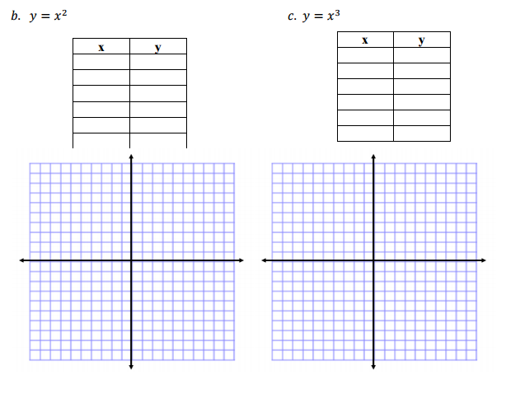
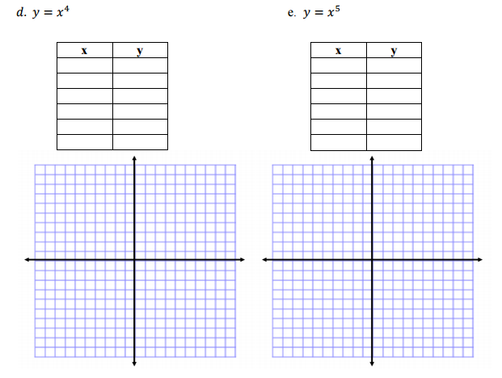
- Compare these five graphs. By looking at the graphs, describe in your own words how 𝑦 = 𝑥² is different from 𝑦 = 𝑥⁴. Also, how is 𝑦 = 𝑥³ different from 𝑦 = 𝑥⁵?

- Here are 8 polynomial functions and their accompanying graphs that we will use to refer back to throughout the task.

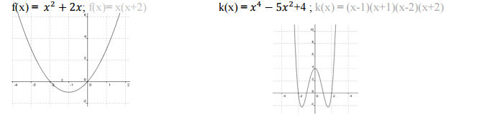
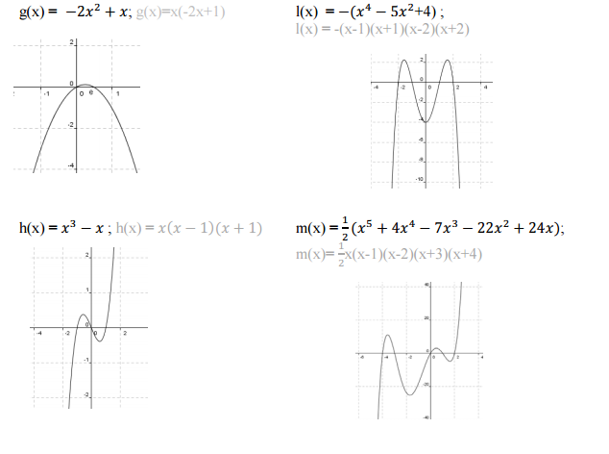
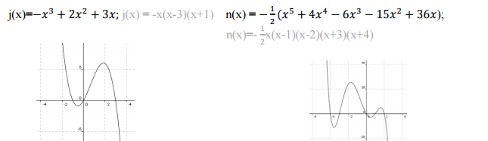

Each of these equations can be re-expressed as a product of linear factors by factoring the equations, as shown below in the gray equations.

- List the x-intercepts of j(x) using the graph above:

- How are these intercepts related to the linear factors in gray?

- Why might it be useful to know the linear factors of a polynomial function?

- For review, factor the following second degree polynomials, or quadratics.

    - 𝑦 = 𝑥² − 𝑥 – 12

    - 𝑦 = 𝑥² + 5𝑥 – 6

    - 𝑦 = 2𝑥² − 6𝑥 − 10

- Using these factors, find the roots of these three equations.

- Sketch a graph of the three quadratic equations above without using your calculator and then use your calculator to check your graphs.

You can factor some polynomial equations and find their roots in a similar way
- Try this one: 𝑦 = 𝑥⁵+ 𝑥⁴ − 2𝑥³

- What are the roots of this fifth order polynomial function?

- How many roots are there?

- Why are there not five roots since this is a fifth degree polynomial?

- Check the roots by generating a graph of this equation using your calculator.

- For other polynomial functions, we will not be able to draw upon our knowledge of factoring quadratic functions to find zeros. For example, you may not be able to factor 𝑥³ + 8𝑥² + 5𝑥 − 14 , but can you still find its zeros by graphing it in your calculator? How?

Write all the zeros of this polynomial function.

- Symmetry

The first characteristic of these 8 polynomials functions we will consider is symmetry.

- Sketch a function you have seen before that has symmetry about the y-axis.
Describe in your own words what it means to have symmetry about the y-axis.

What is do we call a function that has symmetry about the y-axis?
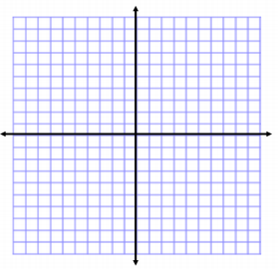
- Sketch a function you have seen before that has symmetry about the origin.
Describe in your own words what it means to have symmetry about the origin.

What do we call a function that has symmetry about the origin?

- Using the table below and your handout of the following eight polynomial functions, classify the functions by their symmetry
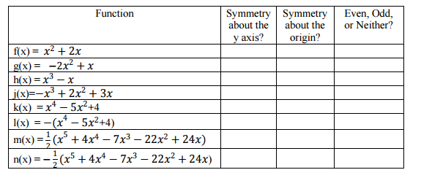
- Now, sketch your own higher order polynomial function (an equation is not needed) with symmetry about the y-axis.

- Now, sketch your own higher order polynomial function with symmetry about the origin.

- Using these examples from the handout and the graphs of the first through fifth degree polynomials you made, why do you think an odd function may be called an odd function? Why are even functions called even functions?

- Why don’t we talk about functions that have symmetry about the x-axis? Sketch a graph that has symmetry about the x-axis. What do you notice?

- Domain and Range
Another characteristic of functions that you have studied is domain and range. For each polynomial function, determine the domain and range.

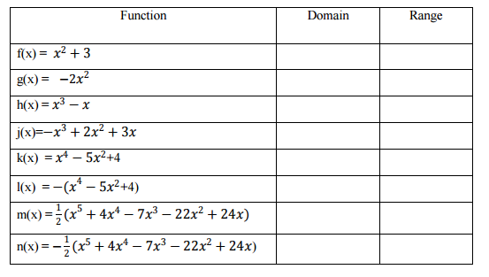
- Zeros

- We can also describe the functions by determining some points on the functions. We can find the x-intercepts for each function as we discussed before. Under the column labeled “x-intercepts” write the ordered pairs (x,y) of each intercept and record the number of intercepts in the next column. Also record the degree of the polynomial.

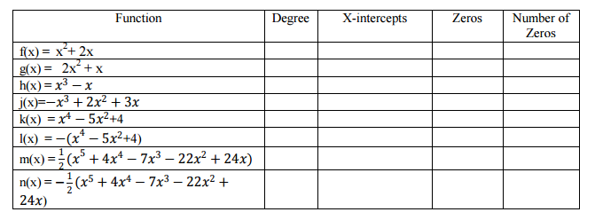
- These x-intercepts are called the zeros of the polynomial functions. Why do you think they have this name?

Function | Degree | X – Intercepts | Zeros | Number of Zeros
𝑦 = 𝑥²
𝑦 = 𝑥²(𝑥 − 1)(𝑥 + 4)
𝑦 = 𝑥(𝑥 − 1)²

- Fill in the column labeled “Zeros” by writing the zeros that correspond to the x-intercepts of each polynomial function, and also record the number of zeros each function has.

- Make a conjecture about the relationship of degree of the polynomial and number of zeros.

- Test your conjecture by graphing the following polynomial functions using your calculator: 𝑦 = 𝑥², 𝑦 = 𝑥²(𝑥 − 1)(𝑥 + 4), 𝑦 = 𝑥(𝑥 − 1)².

- End Behavior

- In determining the range of the polynomial functions, you had to consider the end behavior of the functions, that is the value of f (x) as x approaches infinity and negative infinity. Polynomials exhibit patterns of end behavior that are helpful in sketching polynomial functions.

- Graph the following functions #1 - #12 on your calculator.
- Make a rough sketch next to each one and answer the following:
- Is the degree even or odd?
- Is the leading coefficient, the coefficient on the term of highest degree, positive or negative?
- Does the graph rise or fall on the left? On the right?

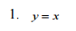  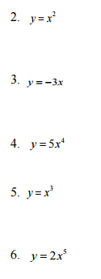 | 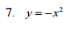  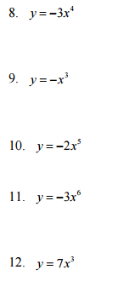
- Write a conjecture about the end behavior, whether it rises or falls at the ends, of a function of the form f(x) = ax^{n} for each pair of conditions below. Then test your conjectures on some of the 8 polynomial functions graphed on your handout.

- Condition a: When n is even and a > 0,

- Condition b: When n is even and a < 0,

- Condition c: When n is odd and a > 0,

- Condition d: When n is odd and a < 0,

- Based on your conjectures in part (b), sketch a fourth degree polynomial function with a negative leading coefficient.

- Now sketch a fifth degree polynomial with a positive leading coefficient.

Note we can sketch the graph with the end behavior even though we cannot determine where and how the graph behaves otherwise without an equation or without the zeros.

- If we are given the real zeros of a polynomial function, we can combine what we know about end behavior to make a rough sketch of the function.
Sketch the graph of the following functions using what you know about end behavior and zeros:

𝑓(𝑥) = (𝑥 − 2)(𝑥 − 3) 𝑓(𝑥) = −𝑥(𝑥 − 1)(𝑥 + 5)(𝑥 − 7)

- Critical Points

Other points of interest in sketching the graph of a polynomial function are the points where the graph begins or ends increasing or decreasing. Recall what it means for a point of a function to be an absolute minimum or an absolute maximum.

- Which of the twelve graphs from part 6a have an absolute maximum?

- Which have an absolute minimum?

- What do you notice about the degree of these functions?

- Can you ever have an absolute maximum AND an absolute minimum in the same function? If so, sketch a graph with both. If not, why not?

- For each of the following graphs from the handout, locate the turning points and the related intervals of increase and decrease, as you have determined previously for linear and quadratic polynomial functions. Then record which turning points are relative minimum (the lowest point on a given portion of the graph) and relative maximum (the highest point on a given portion of the graph) values.

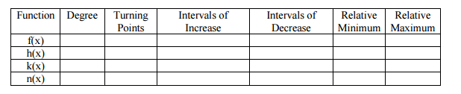

- Make a conjecture about the relationship of the degree of the polynomial and the number of turning points that the polynomial has. Recall that this is the maximum number of turning points a polynomial of this degree can have because these graphs are examples in which all zeros have a multiplicity of one.

- Sometimes points that are relative minimums or maximums are also absolute minimums or absolute maximum. Are any of the relative extrema in your table also absolute extrema?

- Putting it all Together:

Now that you have explored various characteristics of polynomial functions, you will be able to describe and sketch graphs of polynomial functions when you are given their equations.

- If I give you the function: f (x) = (x − 3)(x −1)² then what can you tell me about the graph of this function? Make a sketch of the graph of this function, describe its end behavior, and locate its critical point and zeros.

