Name: ________________________________________________ Date: _______________________

**Mutually Exclusive Practice**

1. Determine if the following events are mutually exclusive or overlapping.
   1. **The experiment is rolling a die.**

**The 1st event:** the number is greater than 3

**The 2nd event:** the number is even.

* 1. **The experiment is year in school.**

**The 1st event:** the person is a senior.

**The 2nd event:** the person is a junior.

* 1. **The experiment is answering multiple choice questions.**

**The 1st event:** the correct answer is chosen

**The 2nd event:** the answer A is chosen.

* 1. **The experiment is selecting a chocolate bar.**

**The 1st event:** the bar has nuts

**The 2nd event:** the bar has caramel.

1. One card is randomly drawn from a deck of 52 cards. The card is face down on the table. What is the probability of getting a Jack or a Spade?
2. **Dice**. Use the general addition rule to compute the probability that if you roll two six-sided dice.

a) you get doubles or a sum of 4

b) you get doubles or a sum of 7

c) you get a 5 on the first die or you get a 5 on the second die.

1. Use the Venn Diagram to answer the following questions.

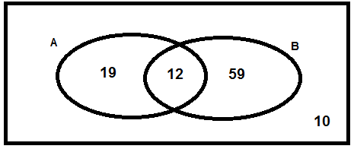

1. P(A) ___________ b) P(B) ___________ c) P(B)’___________

d) _________ e) _________

1. When you arrive home today, you find 27 cupcakes in a large circular plate. There are 13 that have icing 11 have sprinkles, and 4 have both.

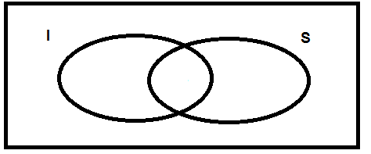

1. P(I) ___________ b) P(S) ___________

c) _________ d) _________

1. Use the data below to find each of the following probabilities.

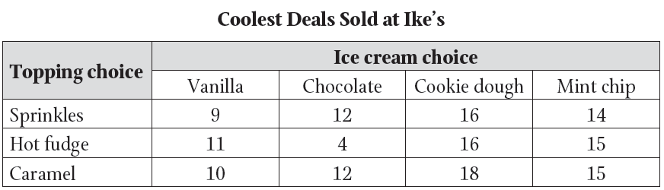

a) P(Chocolate) ____________ b) P(Chocolate)’ _____________

c) P(Sprinkles ∩ Cookie Dough) ____________ d) P(Caramel ∪ Vanilla) _____________