# Right Triangle Trig NAME: ____________________

GSE Geometry

1 a. Find the 3 trig ratios from Angle A and Angle B.

b. How do the ratios compare for the two angles?

2. ABC is a right triangle. One of the acute angles has a cosine of 1/2. What is the sine of that same angle? What is the sine of its complement?

Solve for the missing side or angle using Trig Ratios (sin, cos, tan).

3. 4. 5.

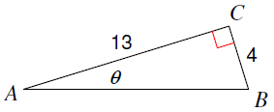 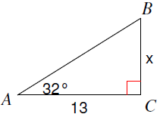 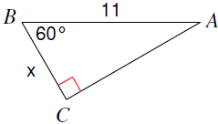

6. 7. 8.

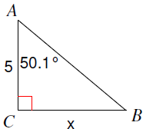 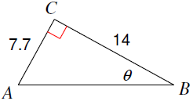 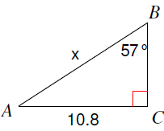

Solve for all of the missing parts of the triangle using Trig Ratios (sin, cos, tan).

9. 10.

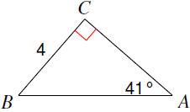 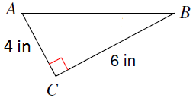

AB = ____________ AB = ____________

AC = ____________ = ____________

= ____________ = ____________

Application Problems:

1. An 8 foot ladder is leaning against a wall so that the base is 5 feet from the base of the wall. What angle does the ladder make with the ground? Round to the nearest tenth.
2. A surveyor is standing 25 feet from a building and is looking at the top with an angle of elevation of 65°. How tall is the building? Round to the nearest tenth.
3. Bob is looking at a helicopter that is flying 1,000 feet above the ground. Bob is 1,500 feet from the helicopter. At what angle of elevation is Bob looking at the helicopter? Round to the nearest tenth.
4. A kite is being flown using 150 yards of string. The kite has an angle of elevation with the ground of 65 degrees. How high above the ground is the kite?
5. A 5.5 foot person standing 20 feet from a street light casts a 12 foot shadow. What is the height of the streetlight?

16. Find the area.

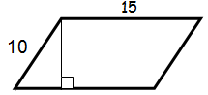

**50°**