Name: ________________________________________________ Date: _______________________

Supplementary and Complementary Angles Homework

Name the figures described. Use the figure for 1-6.
2
1
B
D
C
A
3
4
•
•
•
•
•
X
1. Two acute angles. _________________
- Two obtuse angles. ___________________
- Two pairs of vertical angles. _________________________
- Four pairs of adjacent angles. _______________________________
- Four pairs of supplementary angles. ___________________________
- Two supplements of ∠AXC. ____________________________

- Suppose ∠1 and ∠2 are known to be complementary. If m∠1 = 20°, then m∠2 =____.
- Suppose ∠3 and ∠4 are known to be supplementary. If m∠3 = 40°, then m∠4 = ____.

For problems 9-12, if ∠1 and ∠2 are complementary angles, state the numerical value of x.

9. m∠1 = 2x, m∠2 = 3x | - m∠1 = x, m∠2 = x + 20
11. m∠1 = 2x , m∠2 = x | - m∠1 = 30 + x, m∠2 = 40 + x

For problems 13-16, if ∠3 and ∠4 are supplementary angles, state the numerical value of y.

13. m∠3 = 2y, m∠4 = 3y – 15 | - m∠3 = y + 10, m∠4 = 3y – 10
15. m∠3 = 5y , m∠4 = y | - m∠3 = 160 – y, m∠4 = 170 – y

- Two angles are supplementary. The measure of one is five times the measure of the other angle. Find each angle. ___________ | - Two angles are complementary. The measure of one is 4/5 the measure of the other. Find each angle. _____________

Solve.

_____ 19. The measure of an angle is 30 more than its complement. Find the measure
_____ of the angle and its complement.

_____ 20. The measure of an angle is the same as the measure of its complement.
Find the measure of the angle.

_____ 21. The measure of an angle is 20 less than the measure of its supplement.
_____ Find the measure of the angle, the measure of its supplement, and the
measure of its complement.

_____ 22. The measure of an angle is twice that of its supplement. Find the measure of
_____ the angle and its supplement.

_____ 23. ∠D and ∠E form a linear pair and m∠E = 3x m∠D = x. Find the measure of
_____ each angle and the measure of the complement of ∠D.

24. Find all the missing angles given m∠1 = 90°, m∠2 = 34°, and m∠6 = 137°.
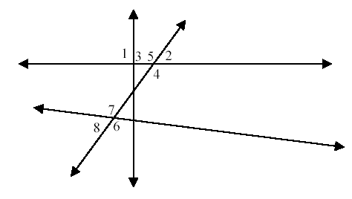

m∠3 = _______

m∠4 = _______

m∠5 = _______

m∠7 = _______

m∠8 = _______

