Use the given information to mark the diagram appropriately. Fill in the congruence statement and name the reason (**SSS**, **SAS**, **AAS**, **ASA**, or **HL**).

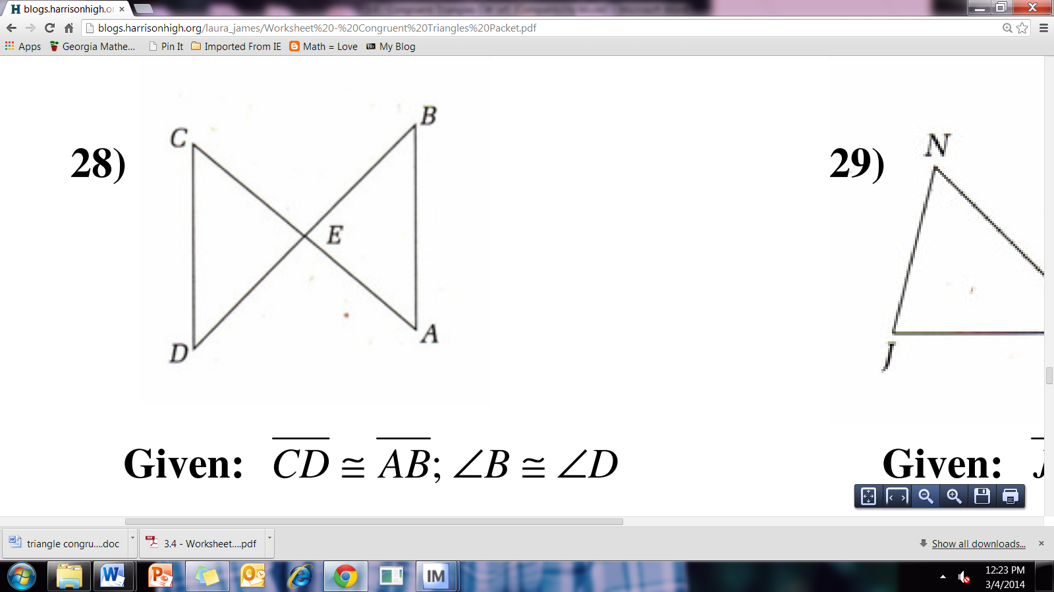

28. **Given: ≅; **B ≅ D

CDE ≅  by ______

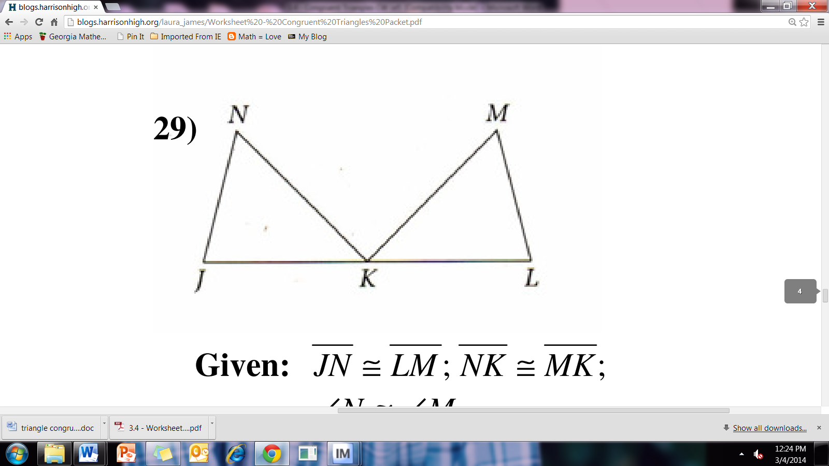

29. **Given: ≅; ≅; **N ≅ M

JKN ≅  by ______

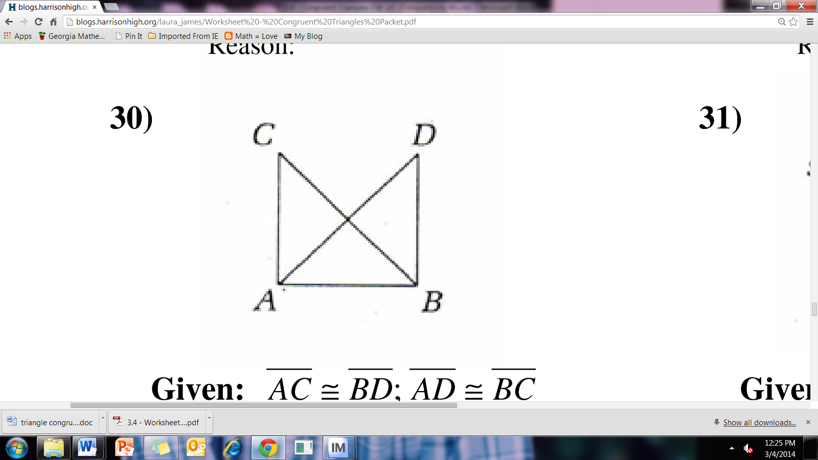30. **Given: ≅; ≅**

ABC ≅  by ______

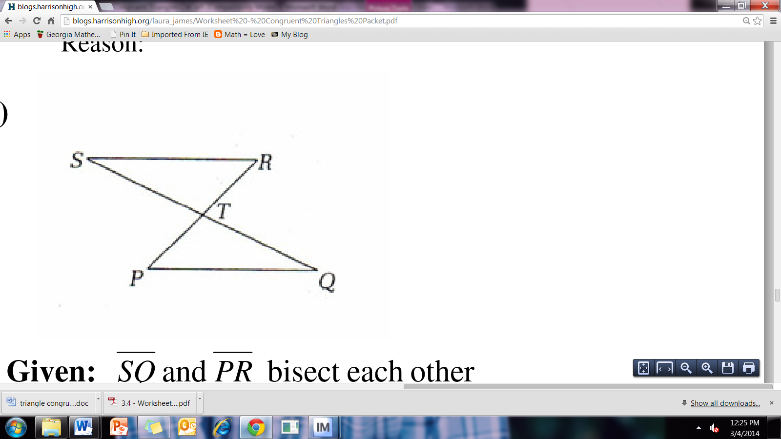31. **Given: **and ****bisect each other

RST ≅  by ______

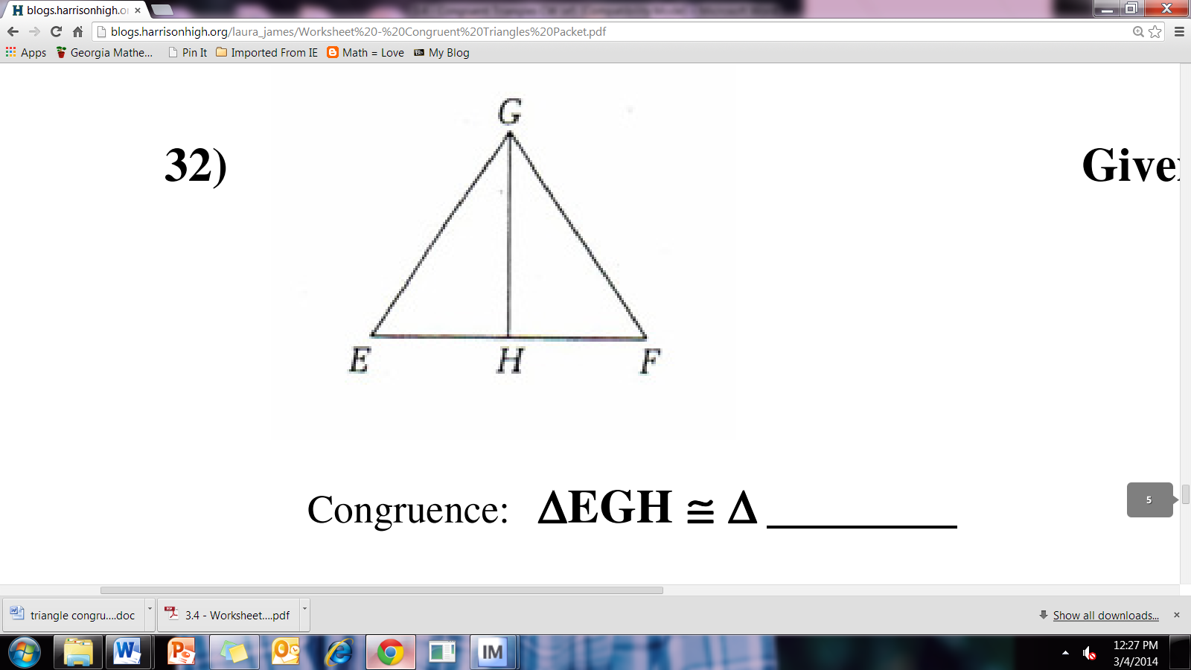32. **Given: **bisects EGF; **≅**

EGH ≅  by ______