~Circumference and Arc Length of Circles Notes~
UNIT QUESTION: What special properties are found with the parts of a circle?
MMC9-12.G.C.1-5,G.GMD.1-3
Today’s Question: How do we find the arc length of a sector?
MMC9-12.G.C.5
2 types of Answers
Rounded | Exact
- Type the Pi button on your calculator  - Toggle your answer  - Round | - Type the Pi button on your calculator  - Pi will be in your answer  - TI 36X Pro gives exact answers

- Circumference:

- Formulas:

Find the EXACT circumference
- r = 14 feet | - d = 15 miles

Find the circumference. Round to the nearest tenth.
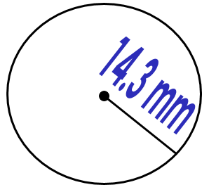 | 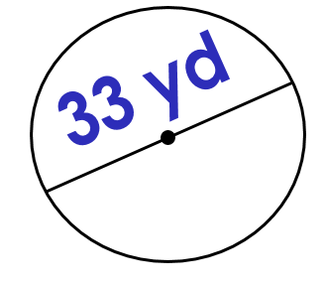

- A circular flower garden has a radius of 3 feet. Find the circumference of the garden to the nearest hundredths.

- Arc Length:

- Formula:

- Find the Arc Length. Round to the nearest hundredths | 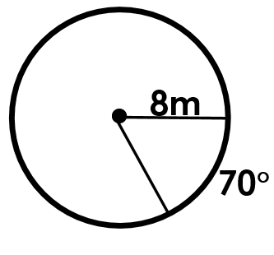
- Find the exact Arc Length. | 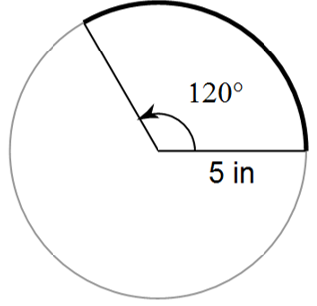
- Find the radius. Round to the nearest hundredth. | 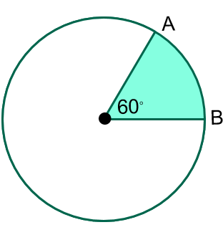
- Find the circumference. Round to the nearest hundredth. | 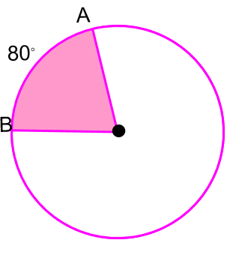
- Find the radius of the unshaded region. Round to the nearest tenth. | 