~Translation Notes~

- Translate the image by (x – 8, y + 2)

- Translate the image by (2x + 2, y – 3)

- Find the pre-image (x + 12, y – 17)

B’(5, -29)
A’(20, -19)
T’(21, -4)

- Translation: 1 unit left  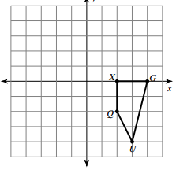 | - Translation: 1 unit right and 2 units down  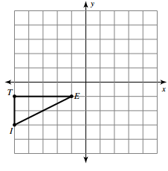
- Write a rule to describe each transformation.  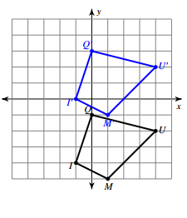 | - Write a rule to describe each transformation.  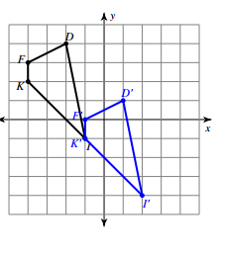
- Write a rule to describe each transformation.  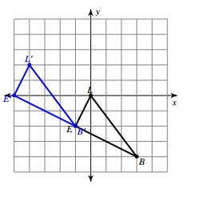 | - Write a rule to describe each transformation.  