~Inscribed Angles & Quadrilaterals Notes~

* **Inscribed Angle –**
* **Formula –**

**Examples of Inscribed Angles:**

|  |  |
| --- | --- |
| 1. **Find the value of x and y** |  |
| 1. **If *m*JK = 80° and JMK = 2x – 4, find x.** 2. **If *m* MKS = 56°, find *m* MS.** |  |
| 1. **Find the measure of DOG and DIG**   **\*\* If two ____________ angles intercept the same arc, then they are ___________.** |  |

* **If all the ____________ of a polygon ________the edge of the ________, the polygon is _______________ and the circle is __________________.**

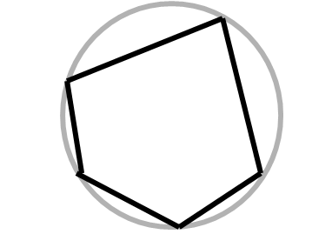

* **Quadrilateral inscribed in a circle: opposite angles are** _______________.

|  |  |
| --- | --- |
|  | **________ + ________ = 180°**  **________ + ________ = 180°** |

* **If a ___________ ____________is inscribed in a circle then the *______________* is the diameter of the circle.**

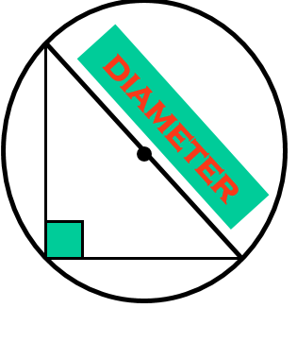

|  |  |
| --- | --- |
| 1. **In** ⊙**J, *m*  3 = 5x and *m* 4 = 2x + 9.**   ***Find the value of x.*** | 1. **In** ⊙**K, GH is a diameter and *m* GNH = 4x – 14. *Find the value of x.*** |
| 1. **Find y and z.** |  |