### Name: __________________________________________ Date: _____________________________

**Segment Lengths with Chords Homework**

Find x.

1) 2)



3) 4)

5) 6)

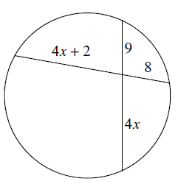 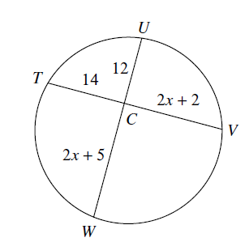

7) 8)

